GET INFORMED: BIBLIOGRAPHY OF GOODREADS!

- Part I: Role of Women

IA. Basic Information: Making the Invisible Visible, even in Academia

Let’s dip our toes into the wide range of issues affecting women and how these, in turn, might affect nation-state outcomes through these five introductory pieces.
* Browse the WomanStats maps at https://www.womanstats.org/maps.html
* United Nations Department of Economics and Social Affairs Statistics (2020) “Thematic Areas,” https://worlds-women-2020-data-undesa.hub.arcgis.com/pages/thematic-areas
Click on each of the 6 “View” buttons to see pertinent statistics on women worldwide.

Now let’s go deeper. First, let us ask ourselves what happens when human knowledge production excludes women, either as subjects or as producers of such knowledge . . .

Bess, Caitlyn (2020) “’Invisible Women’: Excluding 50% of the World’s Population Has Real Consequences,” Ms. Magazine, 9 December, https://msmagazine.com/2020/12/09/invisible-women-excluding-50-percent-of-the-worlds-population-has-real-consequences/

Weingarten, Elizabeth (2018) “The Importance of Teaching Gender in International Relations Classrooms, Pacific Standard, 30 April, https://psmag.com/education/teaching-gender-in-the-classroom-is-a-national-security-issue
Why these womanless National Security classes are no longer justifiable . . . Do you have one this semester? Consider sharing this article with your professor . . .

Does it matter if your economic advisor/professor is male or female? Yes, indeed:
International Labor Organization (2018) “Survey of European Economists Finds Sizable Gender Gaps in Opinions,” 5 February, http://www.ilo.org/global/about-the-ilo/newsroom/news/WCMS_616815/lang--en/index.htm
But are you likely to find women among the ranks of the most eminent economists, from amongst whom are chosen the country’s top economic advisors? Consider the challenges female economists face in their chosen field:
Tankersley, Jima and Noam Scheiber (2018) “Wielding Data, Women Force a Reckoning Over Bias in the Economics Field,” New York Times, 10 January, https://www.nytimes.com/2018/01/10/us/politics/women-economics.html

And what if your foreign policy experts are all men?
Bindi, Federiga and Mimosa Gianmanco (2019) “Missing in Action: The Absence of Women Scholars on Foreign Policy Panels,” Carnegie Endowment, 9 April, https://carnegieendowment.org/2019/04/09/missing-in-action-absence-of-women-scholars-on-foreign-policy-panels-pub-78825
Here’s a handy table on think tanks from 2020 :
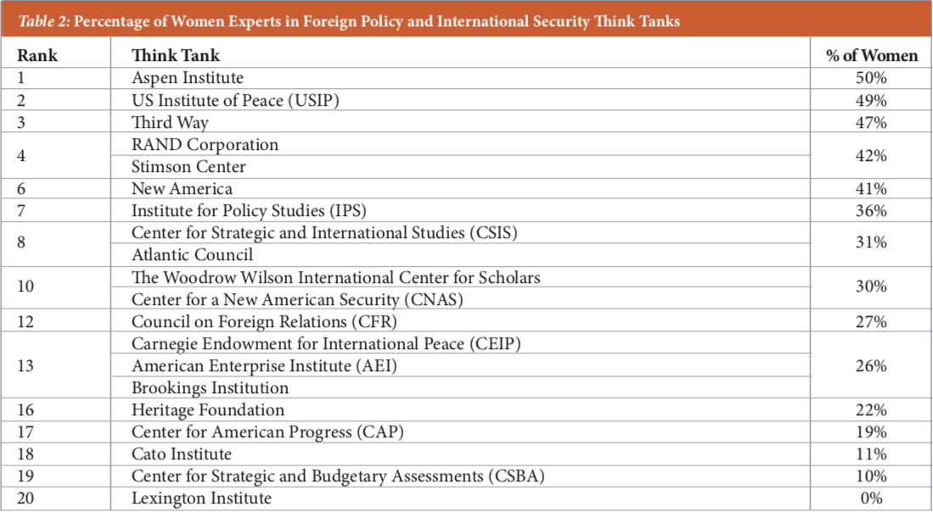
(from: https://www.wiisglobal.org/wp-content/uploads/2020/09/WIIS-Gender-Scorecard-Sept-9-2020.pdf )

I’d love to give you the entire book, Invisible Women: Data Bias in a World Designed for Men by Caroline Criado Perez, to read, but you’re already reading enough. Here’s a book review that will offer some examples from the book, showing how there is a huge blind spot in terms of data concerning women, and thus the world becomes truly “a man’s world.”
Beninger, Stefanie (2019) “Book Review: Invisible Women,” Journal of Macromarketing, 39(4): 467-469, https://journals.sagepub.com/doi/full/10.1177/0276146719875186

There are so, so many women who achievements are completely lost to us: how would our lives be different if we had known about them while growing up?
Mosse, Kate (2021) “Footballers, Fossil Hunters, and Warrior Queens: The Women History Forgot,” The Guardian, 8 March, https://www.theguardian.com/books/2021/mar/08/footballers-fossil-hunters-and-warrior-queens-the-women-history-forgot
(If you’d like to download their first 500 names, it’s at the bottom of this page:
https://www.panmacmillan.com/blogs/fiction/kate-mosse-woman-in-history )

Here’s another strange case of historical invisibility:
Crossette, Barbara. 2000. Working for women’s sexual rights. New York Times, 2 October.
http://www.nytimes.com/2000/10/02/world/working-for-women-s-sexual-rights.html
This article summarizes the sea change that came to the population control movement in the late 1990’s when it discovered, lo and behold! that giving women more rights lowered the birth rate. Read about this sea change here; it was of great historic import, and is a terrific case of the invisibility of the obvious where it concerns women.

And it also took a long time for people to ask whether women might feel differently about foreign policy subjects like the use of force, multilateralism, etc.
Crossette, Barbara. 2000. Divergent views: Women’s global views examined by survey. New York Times, 7 June.
http://www.nytimes.com/2000/06/07/world/women-s-global-views-examined-by-survey.html
Do women evince different attitudes than men towards major national issues, including foreign policy?

One of the first calls for making the women of the world visible in policymaking was this path-breaking speech asserting that women’s rights are human rights.
Clinton, Hillary. 1995. First Lady Hillary Rodham Clinton remarks for the United Nations Fourth World Conference on Women. Prepared for United Nations Fourth World Conference on Women, Beijing, China, 5 September.
http://www.americanrhetoric.com/speeches/hillaryclintonbeijingspeech.htm
In my opinion, this is an extremely important moment in American foreign policy; not only is the text presented, but you can see the video as well. Gotta love that pink pant suit!
ALSO
Years later, Clinton reflected on that moment and what she has learned since then:
Clinton, Hillary Rodham (2020) “Power Shortage,” The Atlantic, October.
https://archive.is/D3NRR

IB. The Wide Range of Issues Concerning Women Globally
Below are readings to orient you to the range of issues concerning women worldwide—

Hudson, Valerie M. (2015) “Leveling the Field: A Global Inventory of Gender Equality for Women,” World Politics Review, September 1

Since the turn of the century, what has gotten better for women? What’s worse?

At least under the law, if not in practice, aren’t women equal in most of the world? Not yet.
Statista (2021) “Only Ten Countries Have Full Equal Rights for Women,” 5 March, https://www.statista.com/chart/17290/countries-with-most-equal-rights-for-women/

Let’s take a bird’s-eye view of how this actually plays out in the life of a woman:
Dixon, Robyn (2015) “Masai Woman Rebels by Insisting on Being Equal,” LA Times, 10 February 2015,
http://www.latimes.com/world/la-fg-c1-kenya-masai-women-20150210-story.html
This article does a nice job of seeing all the interlocking parts of women’s subordination in a traditional culture. The Masai practice brideprice, but how about a dowry society? Let’s see:
Hoque, Kazi Amdadul (2021) “The Story of a Girl Child,” The Daily Star, 11 March, https://www.thedailystar.net/opinion/news/the-story-girl-child-2058305
AND
Al-Bishr, Badriyya. 2005. Saudi author: Imagine you’re a woman. The Middle East Media Research Institute. October 24.
http://www.imra.org.il/story.php3?id=27258
A similar treatment regarding Saudi women: much food for thought here. (Please note that women now have the right to drive in Saudi Arabia. And in June 2021, they gained the right to live apart from their guardian without being arrested.)
AND
Written by a Brazilian, this piece challenges our conventional view of sexism, which she argues comes in several different flavors, not just the burqa-associated type. This is important for us to consider:
Garcia-Navarro, Lourdes (2014) “Which Place is More Sexist: The Middle East or Latin America?” Parallels, 16 March
https://www.npr.org/sections/parallels/2014/03/11/289058115/which-place-is-more-sexist-the-middle-east-or-latin-america

One important ground is what a woman is doing during her day. What does a typical woman’s day actually look like in a nation like Sierra Leone? “Time poverty” is an important concept.
World Vision. 2000. One woman’s day in Sierra Leone. In World Vision Today 3 (summer): 25.
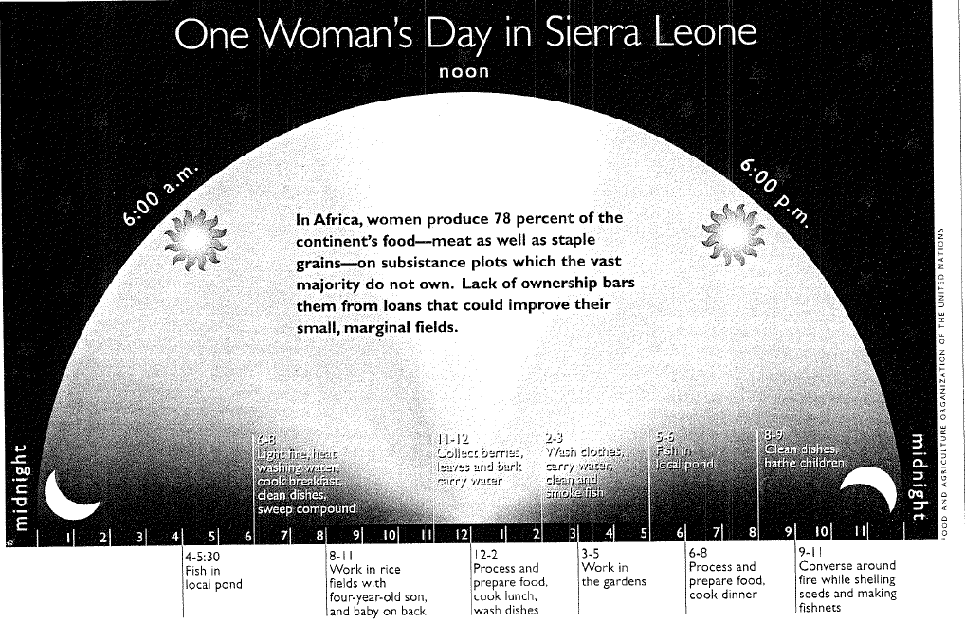

Now, let’s dive a bit deeper into specific issues to be aware of:

One of the most foundational power differentials between the sexes in some countries is whether you get enough to eat:
Heinrich Boell Foundation (2017) “Food Discrimination Against Women in Afghanistan,” ReliefWeb, 7 August, https://reliefweb.int/report/afghanistan/food-discrimination-against-women-afghanistan
Also see this little 2 minute 46 second video called “Eggs”: How does a small thing like differential feeding during childhood affect much, much larger things? https://www.youtube.com/watch?v=E8Mr40MDgks&index=2&t=0s&list=PL2zMrq22-Y2vhQpp7V9H2v5qqf0ZLqh7-
Indeed, the UN found that 60% of chronically hungry persons were female:
UNWomen (2012) “Facts and Figures,” http://www.unwomen.org/en/news/in-focus/commission-on-the-status-of-women-2012/facts-and-figures

I guess even prior to whether you have enough to eat is whether you are allowed to live if you are discovered to be a girl before or right after being born:
It’s a Girl, Movie Trailer, 2012: http://www.itsagirlmovie.com/

Another basic human need is sanitation; yes, there is a gender gap there, too.
Please first see this excellent 4 minute YouTube video by WaterAid to see the linkage to women’s situation drawn more precisely: http://www.youtube.com/watch?v=u8P636QQ8kE
Here is more on the topic:
Bohn, Lauren (2014) “It’s Time to Give a Shit About Toilets,” Foreign Policy, November 20, 2014, http://foreignpolicy.com/2014/11/20/its-time-to-start-giving-a-shit-about-toilets/ .
Related: Caspani, Maria (2015) “What Kills More Women than AIDS and Breast Cancer? Dirty Water,” Thomson Reuters, March 6, 2013, http://www.trust.org/item/20150306045758-ivgpx/?source=dpMostPopular

Here is another issue that was unseen until a “gender lense” was adopted:
Wolfe, Lauren (2014) “Why Are So Many Women Dying of Ebola?” Foreign Policy, 20 August
http://www.foreignpolicy.com/articles/2014/08/20/why_are_so_many_women_dying_from_ebola
75% of victims in the recent Ebola epidemic were women . . . Without a gender analysis, you won’t understand why.
ALSO
World Bank (2013) “Improving Women’s Odds in Disasters,” 12 December
http://www.worldbank.org/en/news/feature/2013/12/12/improving-women-disasters
Women are also much more likely to die in natural disasters such as cyclones and tsunamis . . . Again, you need gender analysis to figure out why.

I give you these next two articles because I want you to be aware that the generic category of “women” has many subcategories, and some are more overlooked than others, even though their situation may be dire. One such subcategory is “widows,” who, in many cultures, face enormous challenges. Notice the role of patrilocal marriage in both these articles.
Burns, John F. 1998. Once widowed in India twice scorned. New York Times, 29 March.
http://www.nytimes.com/1998/03/29/world/once-widowed-in-india-twice-scorned.html?scp=1&sq=burns%201998%20widowed%20India&st=cse
Africa also has serious issues regarding the treatment of widows:
Adebayo, Bukola (2020) “Her Husband Died,” CNN, 27 March
https://www.cnn.com/2020/03/27/africa/as-equals-nigeria-widow-rites-intl/index.html
RELATED:
Once you are an elderly widow, you are also fair game for being accused of witchcraft if anything bad happens in the community:
Telesur (2017) “479 Women Accused of Witchcraft Killed in Tanzania,” 31 July
https://www.telesurenglish.net/news/Report-479-Women-Accused-Of-Witchcraft-Killed-in-Tanzania-20170731-0029.html
There are quite a few nations in which women are still killed because they are suspected of witchcraft--you can find this in India, in Papua New Guinea, and many, many other places.

There are also other minefields for women; is a woman’s life worth more than her modesty?
Pesantez, Nathaly (2015) “Woman Drowns After Father Prevents Lifeguards from Saving Her,” Opposing Views, August 27, 2015
https://www.opposingviews.com/i/world/woman-drowns-after-father-prevents-lifeguards-rescuing-her
Why would a father feel that rescuing his daughter would be worse than death? I give you this article because it makes starkly clear what the consequences of an honor/shame approach to life are.
AND it is not just fathers—it can also be state representatives, such as the police:
BBC (2002) “Saudi Police Stopped Fire Rescue,” 15 March, http://news.bbc.co.uk/2/hi/1874471.stm

As a result of honor and safety concerns, women’s mobility may be far more limited than that of men. This is a worldwide survey:
Chadwick, Lauren (2021) “83% of Young Women Limit Movement to Avoid Harassment,” Euronews, 8 March, https://www.euronews.com/2021/03/08/international-women-s-day-83-of-young-women-limit-movement-to-avoid-harassment-survey-says
AND In addition to a woman self-limiting her movements, there are societies in which her male kin can legally limit her movements:
Dampf, Andrew (2021) “Barred From Travel By Husband, Iran Ski Coach Works Remotely.” AP News, 18 February, https://apnews.com/article/iran-skier-womens-rights-91a82f9a38a271eabc6abdd270720a17

In countries where women have greater rights, male suicides are far more prevalent than female suicides. In countries where women are severely subordinated, the opposite is true:
Frantz, Douglas, 2000. Turkish women who see death as a way out. New York Times, 3
November.
https://www.nytimes.com/2000/11/03/world/turkish-women-who-see-death-as-a-way-out.html
In many cultures, the only way out for a woman is suicide.
ALSO:
Gall, Carlotta. 2004. For more Afghan women, immolation is escape. New York Times. March 8, A1 and A7.
https://www.nytimes.com/2004/03/08/world/for-more-afghan-women-immolation-is-escape.html This article is on the same topic; the manner of suicide changes according to culture. In Afghanistan, the primary means of female suicide is to set oneself on fire.

Does a mother’s name appear on official documents? In some countries, a woman’s name cannot even be spoken, much less be written down:
Nowrouzi, Mahjooba (2020) “WhereIsMyName: Afghan Women Campaign for the Right to Reveal Their Name,” BBC, 25 July:
https://www.bbc.com/news/world-asia-53436335
Think this only applies in places like Afghanistan? These patrilineal legacies run deep:
Campbell, Lucy (2021) “Marriage Certificates in England and Wales to Include Mother’s Name for the First Time,” The Guardian, 3 May,
https://www.theguardian.com/lifeandstyle/2021/may/04/marriage-certificates-in-england-and-wales-to-include-mothers-names-for-first-time

Speaking about the erasure of mothers, have you ever asked yourself whether disempowering women harms children? Is this another case where invisibility distorts our vision?
Physorg.com. 2008. “Violence Against Women Impairs Children’s Health,” 11 September.
http://www.physorg.com/news140347695.html
Sometimes nations don’t care about women. However, all nations “say” they care about the nation’s children. This interesting article asks if you can sincerely say you care for children if you ignore what is happening to their mothers.
Related:
Phennd “New Report: Poverty Dramatically Affects Children’s Brains,” 15 December 2008
http://phennd.org/update/new-report-poverty-dramatically-affects-childrens-brains/ Another important article, raising the question—is poverty a form of violence against children? This is a topic worth pondering.
Related :
UNICEF, 2007. “The State of the World’s Children 2007; Women and Children: The Double Dividend of Gender Equality,”
https://www.unicef.org/reports/state-worlds-children-2007

How does women’s voice in household decision-making affect children? (More here describing how areas where women are gaining rights are seeing decreases in child mortality: https://www.nytimes.com/interactive/2019/09/17/upshot/child-mortality.html )

Another phenomenon that is increasingly being made “visible” is implicit bias against women—which bias is held by both men and women. I’d like you to be familiar with the concept of “implicit bias,” and this short article does a good job of laying out the current research on the topic.
Urry, Meg (2012) “Why Bias Holds Women Back,” CNN, 1 October, http://www.cnn.com/2012/10/01/opinion/urry-women-science/index.html?hpt=hp_c1
AND see how the UN tracks bias against women, which it calls “massive”:
United Nations (2020) “UNDP Gender Social Norms Index Finds Massive Bias Against Women,” IISD, 26 March, https://sdg.iisd.org/news/undp-gender-social-norms-index-finds-massive-bias-against-women/ )
AND even hurricanes given female names are underestimated—by both men and women!
Kristof, Nicholas (2014) “She Gets No Respect, “ NYT, 12 June
http://www.nytimes.com/2014/06/12/opinion/nicholas-kristof-she-gets-no-respect.html?hp&rref=opinion
AND even your internet search results will be altered based on your sex! If you are a woman, you’ll be shown ads for less-well-paying jobs, for example.
Miller, Clara Cain (2015) “When Algorithms Discriminate,” NYT, July 9, 2015
http://www.nytimes.com/2015/07/10/upshot/when-algorithms-discriminate.html?_r=0

McNeil, Lillian, A. Driscoll, A. Hunt (2015) “What’s in a Name? Exposing Gender Bias in Student Ratings of Teaching,” Innovative Higher Education, August 40(4): 291-303
http://link.springer.com/article/10.1007/s10755-014-9313-4
AND
What happens when a man and a woman trade email signatures for a few days? A must-read!
Mooney, Sarah and Carly Stern (2017) “Man Switches Email Signatures with His Female Colleague for a Week,” DailyMail, 10 March, https://archive.is/yXJOz

OK, to end this section of readings, we would be completely remiss if we did not touch on the single worst dimension of women’s disempowerment worldwide—MVAW, or male violence against women. Let’s start with a global overview—1 in 3 lifetime risk of IPV (intimate partner violence):
World Health Organization (2021) “Violence Against Women,” 9 March, https://www.who.int/news-room/fact-sheets/detail/violence-against-women
AND
Consider also that IPV may involve coerced debt or coerced childbearing as control mechanisms:
Coerced debt: Sharp-Jeffs, Natalie (2020) “Forcing Women into Debt is a Marker of Domestic Abuse,” The Independent, 19 September
https://archive.is/iHfok
AND
Coerced pregnancy: Fiore, Kristen (2010) “When Partner Abuse Leads to Pregnancy,” ABCNews, 22 January, https://abcnews.go.com/Health/Wellness/domestic-abuse-abusive-men-sabotage-birth-control/story?id=9639340
(Note that coerced pregnancy can even be part of trafficking:
Jewers, Chris (2020) “Nigerian Baby Factory Where Men Were Hired to Impregnate . . . “ 2 December, https://archive.is/P6QrR )
AND notice that IPV is related to other issues, such as AIDS transmission-
Associated Press. 1999. Violence, AIDS pose joint threat to women. Deseret News, 4 March.
https://www.deseret.com/1999/3/4/19432503/violence-aids-pose-joint-threat-to-women-br-abuse-and-rape-help-spread-hiv-virus-u-n-says
BUT
You also have to figure in harm perpetrated by strangers when we discuss MVAW:
Daily Mail (2016) “Terrifying Video of Random Attack,” 25 August, 16 http://www.dailymail.co.uk/news/article-3758488/Terrifying-video-shows-man-mercilessly-punching-woman-broad-daylight-police-say-random-attack.html

Trigger warning on the video! you can read just the text instead. She was just walking down the street in broad daylight in San Francisco . . . Mobility is another huge issue for women; are women safe in public spaces? If not, what happens to their opportunities?
AND
What would happen if we took women’s lives and safety into account in urban planning?
Rao, Ankita (2017) “Sexism and the City,” Motherboard, 15 May, https://motherboard.vice.com/en_us/article/nz8477/sexism-and-the-city
AND how is MVAW related to foreign policy?
Banerjee, Neela. 2003. Rape (and silence about it) haunts Baghdad. NYT, 16 July.
http://www.nytimes.com/2003/07/16/international/worldspecial/16RAPE.html?scp=1&sq=Neela%20Banerjee%202003%20Baghdad&st=cse
I find this a very important article from 2003, and it raises the question of whether women’s security was improved by the removal of Saddam Hussein by American forces. Did the US destroy women’s security by toppling this dictator? Should US foreign policy makers consider what their actions would do to half the population?
AND
Even if you are not physically attacked, consider what a “lifetime of leers” does to you . . .
Valenti, Jessica (2016) “What Does a Lifetime of Leers Do to Us?” NYT, 4 Jun
http://www.nytimes.com/2016/06/05/opinion/sunday/what-does-a-lifetime-of-leers-do-to-us.html

Finally, consider the role of “honor” in harming women:
Deseret News. 2004. Turkey. April 30, A4: (I have reproduced this article below so you don’t have to go looking for it) Scroll down to DATELINE: ANKARA
http://www.deseretnews.com/article/595059784/World-datelines.html?pg=2
Can you be innocent and yet be deemed to be justifiably killed? Only if you are a woman. I give you this tiny article so that Nuran will never be forgotten. I still think about her, and who she might have become if she had had the chance to grow up.

Turkey
ANKARA — Ignoring the pleas of his 14-year-old daughter to spare her life, Mehmet Halitogullari pulled on a wire wrapped around her neck and strangled her — supposedly to restore the family's honor after she was kidnapped and raped. Nuran Halitogullari, buried Thursday in a ceremony attended by women's rights advocates, is the latest victim in a long history of "honor" killings.

Please do not think that MVAW is confined to societies where women are openly subordinated. The West has its own patterns of MVAW, such as the slaughter of an entire family by its father, which I call “massacre by dad”—these killings are becoming more prevalent in the US.
Shapiro, Emily (2019) “Chris Watts’ Daughter’s Heartbreaking Last Words Before He Killed Her: “Daddy, No!”” ABCNews, 7 March, https://abcnews.go.com/US/chilling-confession-chris-watts-told-police-killed-pregnant/story?id=61477303

Even when women are victims of MVAW, the law may not treat them as such:
Mydans, Seth. 2002. In Pakistan, rape victims are the ‘criminals.’ New York Times, 17 May.
http://www.nytimes.com/2002/05/17/international/asia/17RAPE.html?scp=1&sq=Mydans%202002%20Pakistan%20rape&st=cse
If you are not aware of the so-called “zina laws” that still influence women’s fate in Pakistani courts and village councils (though officially these laws have since been repealed), it is important that you learn; this is a good introduction from 2002. Women can be put on extremely unequal ground in the courtroom simply because of their sex. Look at the legal arguments used; look at the treatment of the rapist.
AND
There is a Western version of this as well, such as the de facto decriminalization of rape. Rape victims, in a sense, may not be seen as true victims in the eyes of the law, it seems:
Dearden, Lizzie (2019) “Rape “Decriminalized As Only 1.4% of Reported Attacks Prosecuted in England and Wales,” The Independent, 17 October, https://archive.is/33uR8

One of the most important avenues for women to change their condition is through female exegesis of religious texts. This is an outstanding example. And Sisters in Islam is still going strong—it’s now a transnational movement!
Mydans, Seth. 1996. Blame men, not Allah, Islamic feminists say. New York Times, 10 October.
http://www.nytimes.com/1996/10/10/world/blame-men-not-allah-islamic-feminists-say.html?scp=1&sq=Mydans+blame+men+Allah&st=nyt

WOULD YOU LIKE MORE?

Here are some readings that I thought were either too long, or about too narrow a subject.

Do you know what TROKOSI is? Here’s a good video about the practice: https://www.youtube.com/watch?v=8AnwkixlhxM

This is a glossy, but long treatment on the range of harmful practices against women. There are several tables of data at the end of the publication:
https://www.unfpa.org/sites/default/files/pub-pdf/UNFPA_PUB_2020_EN_State_of_World_Population.pdf

